IN723 Lab 1 MPLS LDP (VIRL)

In this lab we will configure a small MPLS network using LDP signaling. We will observe the establishment of LDP neighbors and the label operations of Push, Swap and Pop. We will also observe PHP (penultimate hop swapping).
- Note – This lab cannot be completed in packet tracer

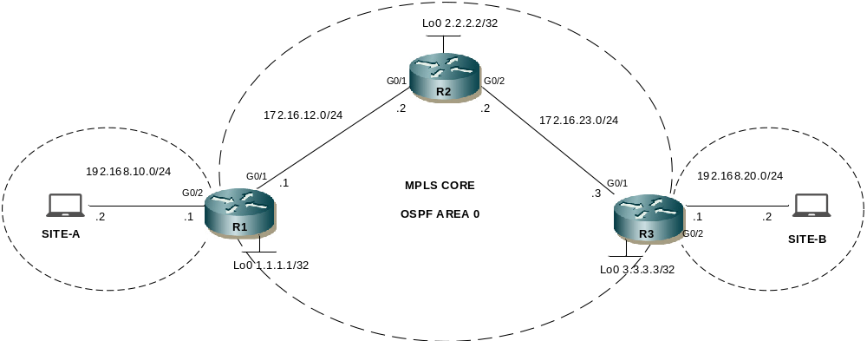

- The switches are used to allow multiple students to simulatenously connect to the routers using telnet.
IP Addressing
Interface | IP Address | Notes
R1 G0/2 | 192.168.10.1/24 | SITE-A LAN
R1 G0/1 | 172.16.12.1/24 | R1 – R2
R1 Lo0 | 1.1.1.1/32 | Loopback
R2 G0/1 | 172.16.12.2/24 | R1 – R2
R2 G0/2 | 172.16.23.2/24 | R2 – R3
R2 Lo0 | 2.2.2.2/32 | Loopback
R3 G0/2 | 192.168.20.1/24 | SITE-B LAN
R3 G0/1 | 172.16.23.3/24 | R2 – R3
R3 Lo0 | 3.3.3.3/24 | Loopback
PC SITEA | 192.168.10.2/24 | Use an IOSv router to simulate
PC SITEB | 192.168.20.2/24 | Use an IOSv router to simulate

Step 1 - Physical
- Physically cable the lab as per the above diagram using IOSv nodes

Step 2 – PC Addressing
- Configure your lab PC (IOSv nodes) as per addressing in the above table
- Configure a default route to the attached router’s G0/1 interface address

Step 3 – IP addressing on R1, R2 & R3
- Configure IP addressing on R1, R2 & R3 as per the diagram / table

Step 4 – OSPF
- Configure single area OSPF between R1, R2 & R3. Use the loopback addresses as router-ids
- Advertise loopbacks vis OSPF (needed for MPLS LDP peering)
- Adertise SITE-A & SITE-B LAN networks via OSPF
- Confirm PC in SITE-A can ping the PC in SITE-B

Step 5 – MPLS LDP
- Confirm CEF is enabled (show ip cef) on each router
- Configure the MPLS label protocol as ldp (mpls label protocol ldp) on each router
- Configure the MPLS ldp router-id as the loopback on each router (mpls ldp router-id loopback0)
- Enable MPLS forwarding on the WAN interfaces of R1, R2 & R3 (mpls ip)

Step 6 – Verify MPLS neighbors
- Verify MPLS forwarding is enabled on the router interfaces
show mpls interfaces
- Verify the status of the Label Distribution Protocol (LDP) discovery process
show mpls ldp discovery
- Verify the status of the LDP neighbor sessions
show mpls ldp neighbor

Step 7 – Verfiy MPLS label mappings
- View the LIB (label information base) to see next-hop labels learned from downstream neighbors (& locally generated) mapped to IP prefixes
show mpls ldp bindings
- View the LFIB (label forwarding information base) to see the local label to next-hop label mappings along with the outgoing interface
show mpls forwarding-table
- Using information from the above 2 commands, write down the expected flow of label operations as traffic is sent from hosts in 192.168.10.0/24 to hosts in 192.168.20.0/24 and vice versa
- What does the tag value imp-null mean?

Step 8 – View MPLS label operation in action
- Send an extended ping from SITE-A PC to SITE-B PC
- Use the debug command to view MPLS forwarding in real time on each of the routers. Confirm the output is as expected from step 8
debug mpls packet
Note - if debugging is already enabled on the router & is not showing up (default for telnet access) then use the command term mon to view the debug output. To turn off debugging use undebug all

